

LEADING THROUGH CHANGE AND TRANSITION:
Change readiness
self-assessment

Servant Leadership Programme
for Congregational Leaders

Change Readiness Self-Assessment Page One
From the web site for leadership class taught by Associate Professor T. J. Jenney at Purdue University http://www.tech.purdue.edu/ols/courses/ols386/crispo/changereadinesstest.doc

Circle the number beside each statement that reflects how accurately the statement describes you.

Change-Readiness Scale:
1 = Not Like Me, 6 = Exactly Like Me
1. I prefer the familiar to the unknown 1 | 2 | 3 | 4 | 5 | 6
2. I rarely second-guess myself 1 | 2 | 3 | 4 | 5 | 6
3. I'm unlikely to change plans once they're set 1 | 2 | 3 | 4 | 5 | 6
4. I can't wait for the day to get started 1 | 2 | 3 | 4 | 5 | 6
5. I believe in not getting your hopes too high 1 | 2 | 3 | 4 | 5 | 6
6. If something's broken, I try to find a way to fix it 1 | 2 | 3 | 4 | 5 | 6
7. I get impatient when there are no clear answers 1 | 2 | 3 | 4 | 5 | 6
8. I'm inclined to establish routines and stay with them 1 | 2 | 3 | 4 | 5 | 6
9. I can make any situation work for me 1 | 2 | 3 | 4 | 5 | 6
10. When something important doesn't work out, it takes me time
to adjust 1 | 2 | 3 | 4 | 5 | 6
11. I have a hard time relaxing and doing nothing 1 | 2 | 3 | 4 | 5 | 6
12. If something can go wrong, it usually does 1 | 2 | 3 | 4 | 5 | 6
13. When I get stuck I'm inclined to improvise solutions 1 | 2 | 3 | 4 | 5 | 6
14. I get frustrated when I can't get a grip on something 1 | 2 | 3 | 4 | 5 | 6
15. I prefer work that is similar and in my comfort zone 1 | 2 | 3 | 4 | 5 | 6
16. I can handle anything that comes along 1 | 2 | 3 | 4 | 5 | 6
17. Once I've made up my mind, I don't easily change it 1 | 2 | 3 | 4 | 5 | 6
18. I push myself to the max 1 | 2 | 3 | 4 | 5 | 6
19. My tendency is to focus on what can go wrong 1 | 2 | 3 | 4 | 5 | 6
20. When people need solutions to problems, they call on me 1 | 2 | 3 | 4 | 5 | 6
21. When an issue is unclear, my impulse is to clarify it right away 1 | 2 | 3 | 4 | 5 | 6

22. It pays to stay with the tried and true 1 | 2 | 3 | 4 | 5 | 6
23. I focus on my strengths and not my weaknesses 1 | 2 | 3 | 4 | 5 | 6
24. I find it hard to give up on something even if its not working out 1 | 2 | 3 | 4 | 5 | 6
25. I restless and fully of energy 1 | 2 | 3 | 4 | 5 | 6
26. Things rarely work out the way you want them to 1 | 2 | 3 | 4 | 5 | 6
27. My strength is to find ways around obstacles 1 | 2 | 3 | 4 | 5 | 6
28. I can’t stand to leave things unfinished 1 | 2 | 3 | 4 | 5 | 6
29. I prefer the main highway to the back roads 1 | 2 | 3 | 4 | 5 | 6
30. My faith in my abilities is unshakable 1 | 2 | 3 | 4 | 5 | 6
31. When in Rome do as the Romans do 1 | 2 | 3 | 4 | 5 | 6
32. I’m a vigorous and passionate person 1 | 2 | 3 | 4 | 5 | 6
33. I’m more likely to see problems than opportunities 1 | 2 | 3 | 4 | 5 | 6
34. I look in unusual places to find solutions 1 | 2 | 3 | 4 | 5 | 6
35. I don’t perform well when there are vague expectations and goals 1 | 2 | 3 | 4 | 5 | 6

Change Readiness Self- Assessment Scoring Sheet

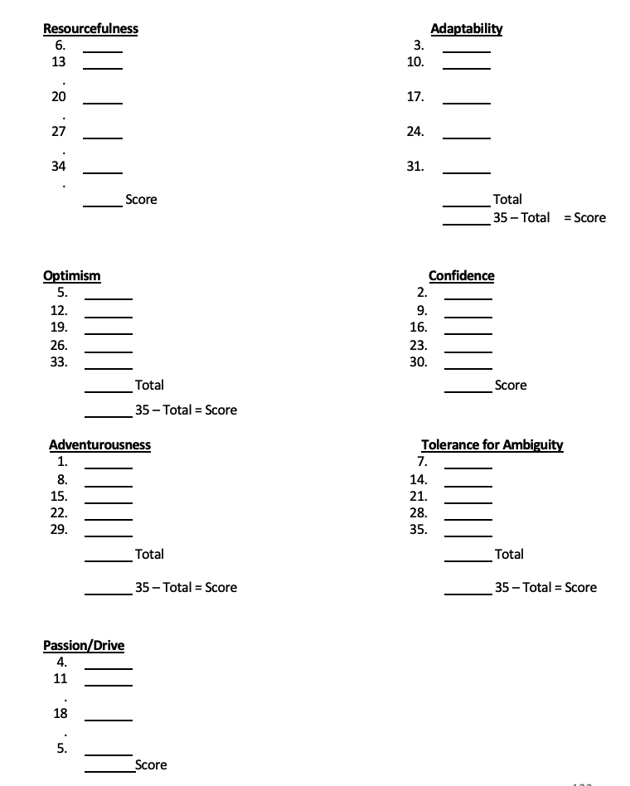
Add the scores for the questions in each category as indicated below.
Note that in some cases the total must be subtracted from 35 to get the score for that trait.

Understanding Your Scores
Note: Optimal range for all categories is between 22 and 26.

Resourcefulness: Resourceful people are effective at taking the most of any situation and utilizing whatever resources are available to develop plans and contingencies. They see more than one way to achieve a goal, and they're able to look in less obvious places to find help. They have a real talent for creating new ways to solve old problems.

When people low in resourcefulness encounter obstacles, they get stuck, dig in their heels, and go back to the old way. Very high scorers (over 26) might overlook obvious solutions and create more work than is necessary.

Optimism: Is the glass half empty or half full? Optimism is highly correlated with Change- Readiness, since the pessimist observes only problems and obstacles while the optimist recognizes opportunities and possibilities.

Optimists tend to be more enthusiastic and positive about change. Their positive outlook is, founded on an abiding faith in the future and the belief that things usually work out for the best. Very high optimism scorers (over 26) may lack critical-thinking skills.

Adventurousness: Two ingredients capture this adventurous spirit: the inclination to take risks and the desire to pursue the unknown, to walk the path less taken. Adventurous people love a challenge.

Since change always involves both risk and the unknown, they usually perform well during organizational shake-ups. They are the pro-actors, the employees who initiate and create change. But very high scores (over 26) may indicate a tendency toward recklessness.

Passion / Drive: Passion is the fuel that maximizes all the other traits. If you have passion, nothing appears impossible. If you don't, change is exhausting. Passion is the individual's level of personal dynamism. It shows up in a person's level of intensity and determination.

To make a new procedure work, to overcome the myriad of problems that any plan for change unwittingly produces, you've got to have passion and enthusiasm. Very high scorers (over 26), however, may mean you're bullheaded, obsessed, and heading for burnout.

Adaptability: Adaptability includes two elements: flexibility and resilience. Flexible people have goals and dreams like everyone else, but they're not overly invested in them. When something doesn't work out, they'll say, "Plan A doesn't work, let's go to Plan B." Resilience is the capacity to rebound from adversity quickly with a minimum of trauma. Failure or mistakes do not throw them. They don't dwell on them and get depressed but bounce back quickly and move on.

Confidence: If optimism is the view that a situation will work out, confidence is the belief in your own ability to handle it. There is situational confidence - "I know I can swim across this channel, learn this program, write this report" - and self-confidence - "I can handle whatever comes down the pike." Self-confidence is the kind of confidence the Change Readiness Scale measures.

High scorers are generally individuals with a strong sense of self-esteem. But more specifically, they believe they can make any situation work for them. Scorers above 26 may indicate a cocky, know-it-all attitude and lack of receptivity to feedback.

Tolerance for Ambiguity: The one certainty surrounding change is that it spawns uncertainty. No matter how carefully you plan it, there is always an element of indefiniteness or ambiguity.

Without a healthy tolerance for ambiguity, change is not only uncomfortable; it's downright scary. But too much tolerance can also get you in trouble. You may have difficulty finishing tasks and making decisions. If you scored over 26 you fall in this category.

Your Profile: You'll probably find you have higher scores on some traits and lower scores on others. This is typical of most profiles and indicates that some of your Change-Readiness traits are more developed than others.

The Change-Readiness Scale is also useful for assessing teams.
Adventurers are great starters, resourceful people are excellent problem solvers, optimists make good cheerleaders, and their input is especially useful when people feel discouraged.

For Reflection

- What strategies do you use to move through change and transition?

- What strategies might you use to develop others in change readiness?

