

personal and spiritual leadershp

Core personal values exercise

Servant Leadership Programme
for Congregational Leaders

Activity: Core Personal Values Exercise
- From the list below, circle every core value that resonates with you. Do not overthink your selections. As you read through the list, simply circle the words that feel like a core value to you personally. If you think of a value you possess that is not on the list, be sure to write it down as well.
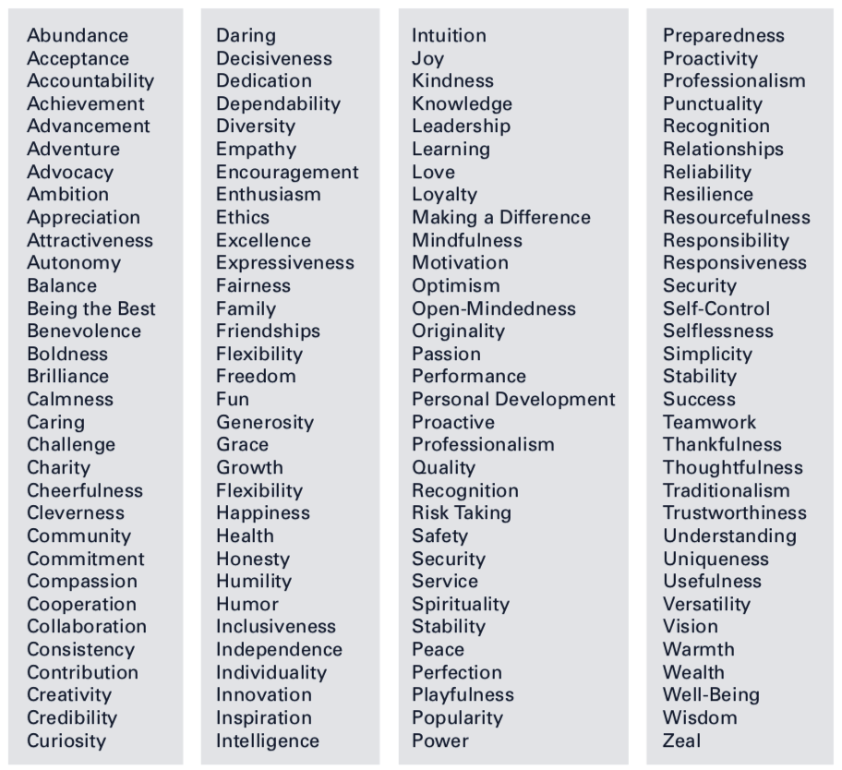
Additional values not listed:
________________________________________________________________________________________________
________________________________________________________________________________________________________________________________________________________________________________________________

Activity: Core Personal Values Exercise, cont.
- Group all similar values together from the list of values you just created. Group them in a way that makes sense to you personally. Create a maximum of five groups. If you have more than five groupings, eliminate the least important. See example below:
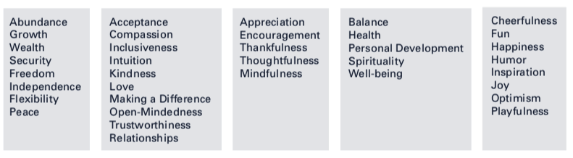

Activity: Core Personal Values Exercise, cont.
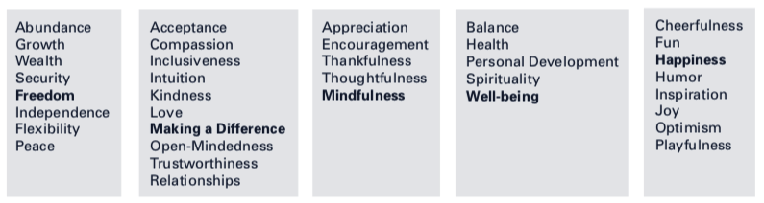
- Choose one work within each grouping that best represents the label for the entire group. Again, do not overthink your labels. There are no right or wrong answers.
You are defining the answer that is right for you. See the example below (the label for each grouping is bolded):

Our personal values shape our behavior and actions. When values are aligned to our actions and behaviors we are satisfied and fulfilled. When there is not alignment between our personal values and the actions we take or the expectations that others have of us, we can experience dissatisfaction or unhappiness.

Activity: Core Personal Values Exercise, cont.
- Plot your five values on the circle below. The closer you place a value to the center of the circle, the more active it is in your life. A value that is less active in your life will be placed farther away from the center. Label each section: Family, Community, Employment/Role in Ministry. Place each of your five values on the circle for each area: Family, Community, Employment/Role in Ministry:



- What areas do you feel you are acting consistently with your personal values?

- What areas feel “out of alignment” with your values?

- What accounts for coherence, lack of coherence?

