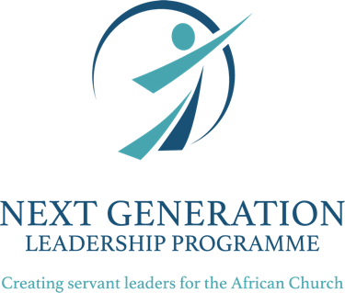

personal and spiritual leadershp

spiritual intelligence self-assessment

Servant Leadership Programme
for Congregational Leaders

Self-Assessment: Spiritual Intelligence
Ken O’Donnell offers 8 questions by which we can assess our spiritual intelligence in day-to-day experiences and interactions. Take a moment to read each question and to write down your immediate thoughts. Once complete, identify your areas of strength, and where you see opportunities to improve. Write down the actions you can take to grow in your SQ.
- How much bilateral respect exists in my relationships?
- How honest am I with others?
- How much dignity do I retain in respecting the dignity of others?
- How tranquil do I remain despite the workload?
- How sensible are my decisions?
- How stable do I remain in upsetting situations?
- How easily do I see virtues in others instead of defects?
- How much time, money and energy and thoughts do I need to obtain a desired result?

